**PROJECT TITLE : Machine Learning Model Deployment with IBM Cloud Watson Studio**

**Phase 1: Problem Definition and Design Thinking**

PROBLEM DEFINITION

The problem you are addressing is the deployment of machine learning models using IBM Watson Studio on the IBM Cloud. Deploying machine learning models can be a complex task, involving multiple steps such as model training, evaluation, packaging, and serving. IBM Watson Studio offers a platform for data scientists and developers to collaboratively build and deploy machine learning models, but it requires effective design and implementation to ensure successful model deployment.

Designing a machine learning model deployment with IBM Cloud Watson Studio can be applied to various real-time problems across different domains. Let's consider a specific real-time problem scenario and outline the steps involved in designing a solution for it.

DESIGN THINKING

Predictive Use Case:

Start by identifying a specific use case for predictive analytics. Examples include predicting customer churn, forecasting product demand, fraud detection, or sentiment analysis.Define the problem statement clearly, including the business objectives and goals you want to achieve with this predictive model.Consider the potential impact of your predictions on the business.

Dataset Selection:

Choose a dataset that is relevant to your predictive use case. The dataset should contain historical data that can be used for training and testing the model.Ensure the dataset is clean, well-structured, and contains the necessary features for your analysis.

If needed, perform data preprocessing, including data cleaning, feature engineering, and handling missing values.

Model Training:

Select an appropriate machine learning algorithm based on the nature of your predictive use case. Common algorithms include regression, classification, clustering, or deep learning models.Split your dataset into training and testing sets to evaluate the model's performance.Use IBM Cloud Watson Studio to create and train your machine learning model. Experiment with different hyperparameters and feature selections to improve model performance.

Evaluate the model's performance using appropriate metrics such as accuracy, precision, recall, or F1-score.

Model Deployment:

Once you have a trained and validated model, deploy it as a web service using IBM Cloud Watson Studio's deployment capabilities.Ensure that the deployed model is scalable and can handle real-timeprediction requests efficiently.Implement version control and monitoring for your deployed model to track its performance over time.

Integration:

Integrate the deployed model into your target applications or systems to make real-time predictions.Consider using RESTful APIs or other integration methods to allow external systems to interact with the model.Implement error handling and logging to ensure the reliabilityof predictions in production.

FLOWCHART

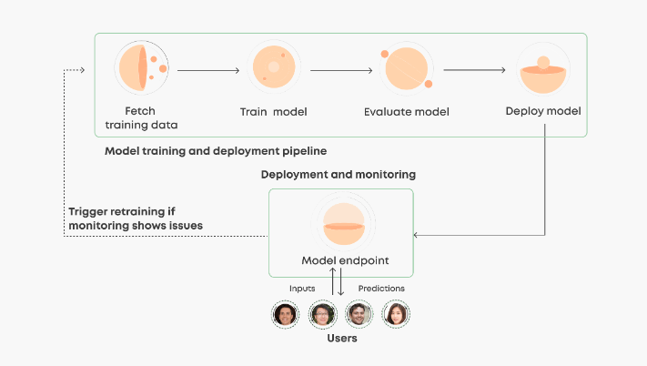

Expected Outcomes

By the end of this project, we anticipate achieving the following outcomes.

1. A user-friendly platform that simplifies predictive analytics with IBM Cloud Watson Studio.

2. Empowered users who can efficiently train, deploy, and integrate machine learning models.

3. Unlocking valuable data-driven insights for improved decision-making.

4. Comprehensive training materials to support user proficiency.

5. A scalable and adaptable solution that can evolve with changing needs.